000님 session 00
Pregnancy
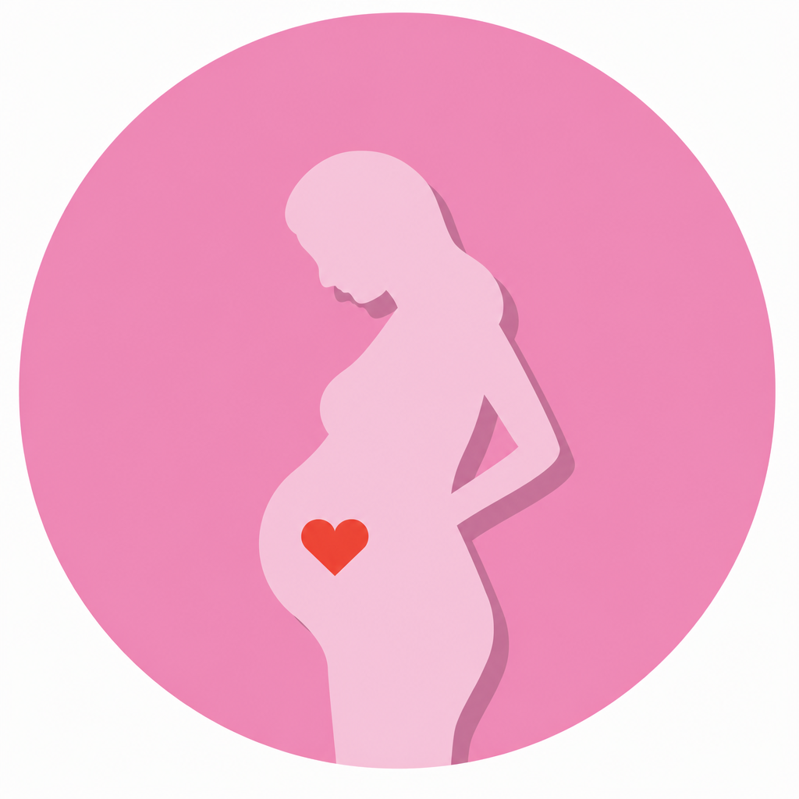
Warm-Up / Vocabulary Preview / Reading / Comprehension

Warm-Up
Q What symptoms are associated with early pregnancy?
Q What do women do if they suspect they are pregnant?
Q In your region, what options do women have for delivering their babies?
Q Are there any special traditions related to pregnancy in Korea?
Q Are baby showers or gender reveal parties common in Korea? Have you ever been to one?
Q What are you most looking forward to about becoming a mom?

Vocabulary Preview
Word | Meaning | Example
home pregnancy test | a test kit you use at home to check if you are pregnant | I took a home pregnancy test, and it was positive!
morning sickness | feeling sick or nauseous in early pregnancy | I've been suffering from morning sickness these days.
due date | the day the baby is expected to be born | My due date is in early December.
trimester /traɪˈmestər/ | one of the three stages of pregnancy | I'm in my second trimester now.
ob-gyn /ˌoʊ.biː.dʒiː.waɪˈen/ | a doctor for pregnancy and childbirth | I have an appointment with my ob-gyn tomorrow.
prenatal checkup | a regular medical visit during pregnancy | I go in for a prenatal checkup every four weeks.
ultrasound | a scan that shows the baby inside the womb | We saw the baby moving during the ultrasound.
heartbeat | the sound of the heart beating | We heard the baby's heartbeat for the first time!
find out the baby's sex | learn if the baby is a boy or a girl | We're going to find out the baby's sex next week.
gestational diabetes /dʒeˌsteɪʃənl ˌdaɪəˈbiːtiːz/ | high blood sugar during pregnancy | I got tested for gestational diabetes last week.
contractions /kənˈtrækʃənz/ | strong, repeated pains before the baby is born | My contractions are about ten minutes apart.
my water broke | the fluid around the baby came out | My water just broke — we need to go to the hospital!
epidural /ˌepɪˈdʊrəl/ | an injection that blocks pain during labor | I'm planning to get an epidural.
C-section /ˈsiː ˌsekʃən/ | surgery to deliver a baby | My first baby was born by C-section.
labor and delivery /ˈleɪbər/ | the process of giving birth | I was in labor for ten hours.
newborn | a baby that was just born | Newborns sleep most of the day.
NICU /ˈnɪkjuː/ | neonatal intensive care unit — for newborns who need special care | The baby stayed in the NICU for a few days.
breastfeed / formula | feed the baby with mother's milk / powdered baby milk | I haven't decided whether to breastfeed or use formula.
postpartum /ˌpoʊstˈpɑːrtəm/ | related to the time after giving birth | Postpartum care is really important in Korea.
announce the pregnancy | tell people that you are pregnant | We announced the pregnancy to our parents first.
the 12-week mark | the point when the pregnancy becomes more stable | We waited until the 12-week mark to tell our friends.
gender reveal /rɪˈviːl/ | an event to share whether the baby is a boy or a girl | We cut a cake at our gender reveal party.
postpartum care center (= joriwon) | a place where moms rest and recover after giving birth | I've already booked a postpartum care center.
miscarriage /ˈmɪsˌkærɪdʒ/ | losing a baby before it is able to be born | The risk of miscarriage goes down after the first trimester.

Reading 1 — Types of Appointments

1 When a woman thinks she might be pregnant, she can take a home pregnancy test. Early signs include a missed period, morning sickness, and fatigue. If the test is positive, the next step is to book an appointment with an ob-gyn and start regular prenatal checkups.

2 In the first trimester, the doctor does an ultrasound to check the baby's heartbeat and confirm the due date. In the second trimester, most women are tested for gestational diabetes — you drink a very sweet drink and then have a blood test. This is also when many parents find out the baby's sex.

3 In the third trimester, checkups become more frequent. The doctor checks the baby's growth, movement, and position. As the due date gets closer, the doctor and the parents also talk about the delivery — for example, whether to get an epidural, and what to do when labor starts.

4 When labor starts, the mother feels contractions, and sometimes her water breaks. When the contractions get closer together, it's time to head to the hospital. If there are complications, the baby may be delivered by C-section. After the birth, the newborn usually stays in the room with the mom, and if the baby needs extra care, the NICU team is there to help.

Reading 2 — Pregnancy & Childbirth Culture in Korea

1 In Korea, many couples keep the news to themselves until the 12-week mark. The first trimester is not considered a “safe” stage yet, so moms-to-be usually announce the pregnancy to friends and coworkers only after 12 weeks.

2 These days, gender reveal events are becoming popular. For example, one partner finds out the baby's sex first and surprises the other — by cutting a cake that is pink or blue inside, or by opening a box full of balloons. It has become a fun way to share the news.

3 The biggest difference from other countries is postpartum care. After giving birth, most Korean moms stay at a postpartum care center, called a joriwon, for about two weeks. It is not a hospital — it is a place where moms rest and recover while trained staff take care of the newborns. Many foreigners find this culture unique to Korea.

Comprehension
Q What are two early signs of pregnancy mentioned in the reading?
Q What happens at the first trimester ultrasound?
Q How is the test for gestational diabetes done?
Q What does the doctor check in the third trimester?
Q What are two signs that labor has started?
Q Why do many Korean couples wait until the 12-week mark to announce a pregnancy?
Q What is a joriwon, and what happens there?

